COMPREHENSIVE CAR SALES DATA ANALYSIS AND VISUALIZATION
CENTRAL TOOL ROOM & TRAINING CENTER
B-36, CHANDAKA INDUSTRIAL AREA, NEAR INFOCITY, BBSR,(O.D) 751024
Department Of PGDTD & CC

DEPARTMENT – DATA ANALYTICS
YEAR – 2025
SUBMITTED BY –
SAMIKSHYA SATPATHY, IPSITA BEHERA, PRIYANSHU ROUT, SAMBIT MAHALIK, SHIBANI SUBHADARSINI, SUCHISMITA BARIK

CENTRAL TOOL ROOM & TRAINING CENTER
B-36, CHANDAKA INDUSTRIAL AREA, NEAR INFOCITY, BBSR,(O.D) 751024
Department Of PGDTD & CC

CERTIFICATE

Certified that Major Project Work entitled “COMPREHENSIVE CAR SALE DATA ANALYSIS AND VISUALIZATION” is a Bonafide work carried out by SAMIKSHYA SATPATHY, IPSITA BEHERA, PRIYANSHU ROUT, SAMBIT MAHALIK, SHIBANI SUBHADARSINI, SUCHISMITA BARIK in particular fulfillment of the requirements for the award of CERTIFICATE COURSE IN DATA ANALYTICS from CENTRAL TOOL ROOM & TRAINING CENTER, Bhubaneswar, during the year 2025. It is certified that all the correction/suggestion indicated for internal assessment have been incorporated in the report. The major project report has been approved as is satisfied the academic requirements in the respect of project work prescribed for PGDTD & CC, CTTC, Bhubaneswar (O.D).
 | ……………………………………  Course  Coordinator | …………………………………..  Examiner

ACKNOWLEDGEMENT
It is our proud privilege and duty to acknowledge the kind of help and guidance received from several people in preparation for this report. It would not have been possible to prepare this report in this form without their valuable help, cooperation, and guidance.
First and foremost, we wish to record our sincere gratitude to Management of this Training Center and to our beloved Principal, Mr. L. Rajasekhar, and Sr. Manager, Mr. Rajan K.M, CTTC, Bhubaneswar. For his constant support and encouragement in preparation of this report and for making the available library and laboratory facilities available needed to prepare this report. Our sincere thanks to Sr. Engineer Mrs. Ritu Maity, CTTC, BBSR. For his valuable suggestions and guidance throughout the period of this report. We express our sincere gratitude to our supervisor Gitanjali Digal of CTTC, Bhubaneswar for guiding us in investigations for this project and in carrying out experimental work. Our numerous discussions with him were extremely helpful. We hold him in esteem for guidance, encouragement, and inspiration received from his.
Last but not the least, we wish to thank our parents for ﬁnancing our studies in this college as well as for constantly encouraging us to learn to be an engineer. Their personal sacriﬁce in providing this opportunity to learn engineering is gratefully acknowledged.

Place: Bhubaneswar GROUP-5

DECLARATION

We the members of group 5 of DATA ANALYTICS course from CENTRAL TOOL ROOM & TRAINING CENTER at CTTC (Central Tool Room & Training Center), Bhubaneswar, hereby declare that this major project work entitled “COMPREHENSIVE CAR SALE DATA ANALYSIS AND VISUALIZATION” which is being submitted by us in the partial fulfillment for the award of the degree of MCCAI, from CTTC, Bhubaneswar is an authentic record carried out during the Training year 2025, under the supervision of Gitanjali Digal of CTTC, Bhubaneswar.

Group-5:
SAMIKSHYA SATPATHY
IPSITA BEHERA
PRIYANSHU ROUT
SAMBIT MAHALIK
SHIBANI SUBHADARSINI
SUCHISMITA BARIK

S. No. | Contents
1  2  3  4  5  6  7  8 | INTRODUCTION  OBJECTIVE  DATA SOURCE  MS EXCEL  MS POWER BI  TABLEAU  PYTHON  CONCLUSION

INTRODUCTION
The automobile resale market is growing rapidly. However, determining a fair resale price for a used car is a complex task involving multiple factors such as brand, model, manufacturing year, kilometers driven, fuel type, transmission, etc. This project aims to develop a machine learning-based car selling price prediction model that helps both buyers and sellers estimate the ideal resale value of a car.
Objective
The primary objective of this project is to explore, analyse, and visualize automobile sales data to identify significant trends, insights, and key performance metrics within the Indian car market. By transforming raw data into visually interactive dashboards, the aim is to facilitate informed decision-making for stakeholders including customers, dealers, market analysts, and business strategists. The analysis focuses on various attributes such as car brand, model, price, year of manufacture, fuel type, owner history, car type, and geographical location. The visualization reveals which car types and brands are popular, how ownership and fuel types affect pricing, and regional trends in car sales across India.

DATA SOURCE: DATA SELL MODEL
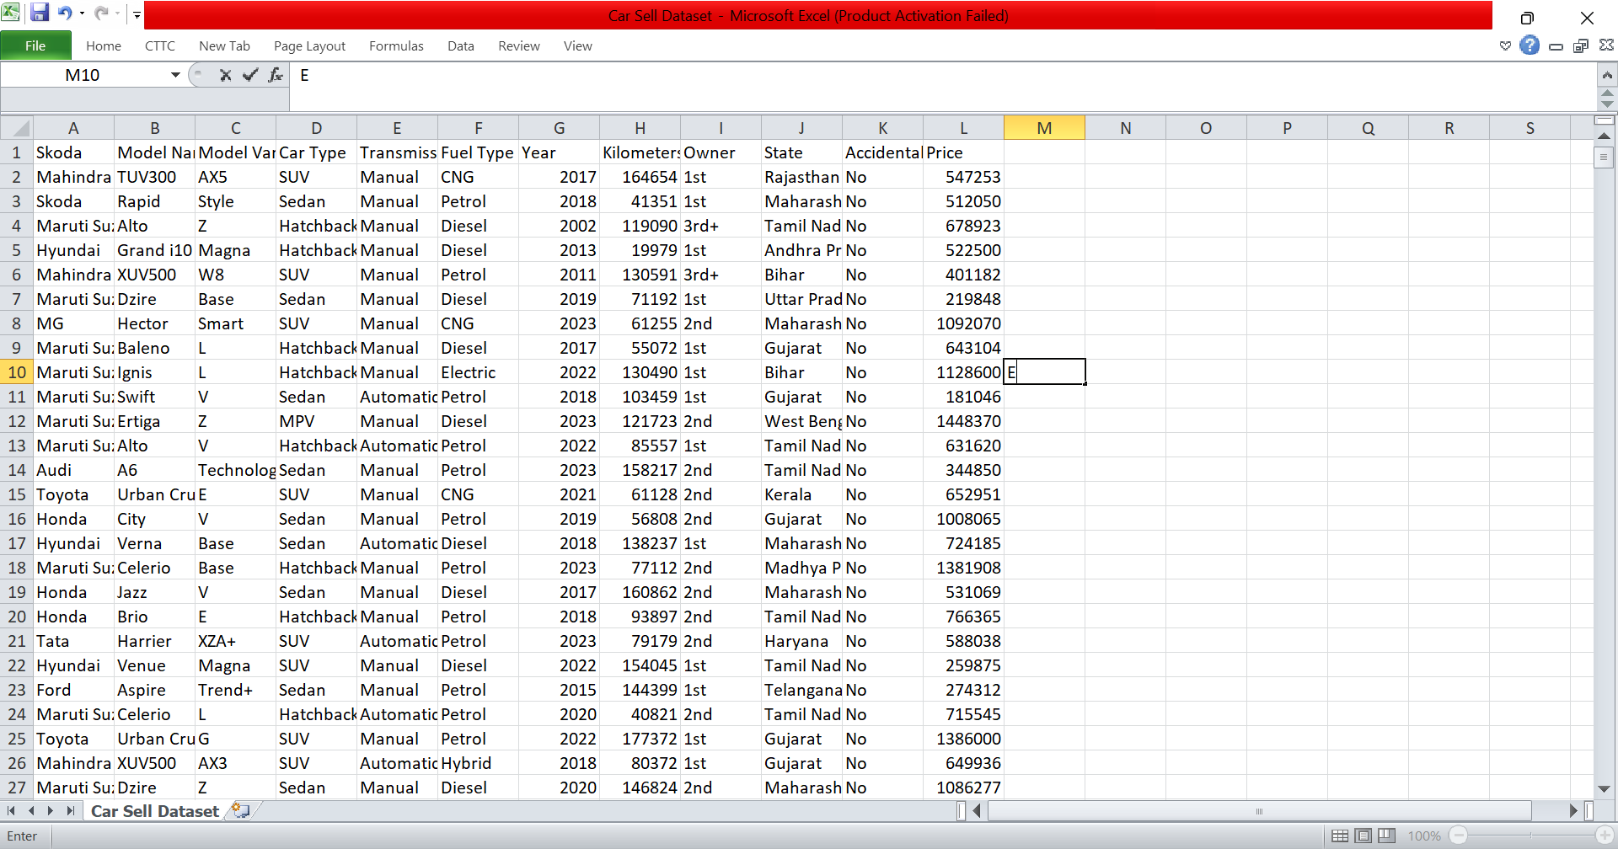
Dataset Description
The dataset contains detailed information about 140905 car sales records in India. Each entry in the dataset includes various parameters describing the car's specifications and market presence. The key columns include:
- Brand: Indicates the manufacturer and along with Model Name
- Model Variant: Specific variant of the car.
- Year: The year the car was manufactured, used to compute car age.
- Fuel Type: Categorical variable indicating whether the car uses Petrol, Diesel, CNG, or other fuels.
- Transmission: Either Manual or Automatic.
- Owner Type: Specifies the number of previous owners (1st, 2nd, etc.), relevant to resale value.
- Kilometre Driven: Total distance driven, an important parameter for price depreciation.
- Price: Final sale price in Indian Rupees.
- Location (State): Used to map sales across geographical areas.
DATA VISUALIZATION
MS-EXCEL
Microsoft Excel is a spreadsheet software developed by Microsoft. It is used for storing, organizing, analyzing and visualizing data in tabular form .
Data Processing:
Created pivot tables for:
- Brand Wise Price
- Fuel wise Total Price
- State wise Price
- Model wise Total Price
- Type of Car Price

Pivot Tables:
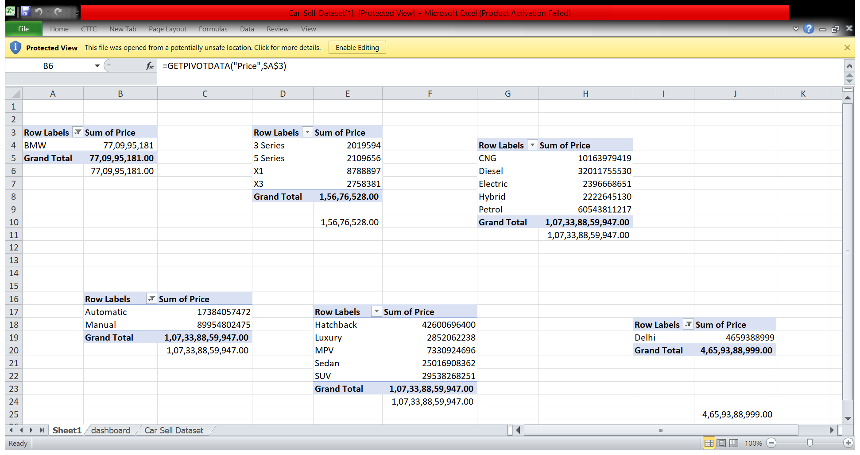
Visualization:
- Doughnut Charts for Fuel wise Total Price
- Stacked Bar Charts for State wise Price
- Pie Chart for Transmission (Manual or Automatic)

DASHBOARD OF CAR SELLING DETAILS USING EXCEL
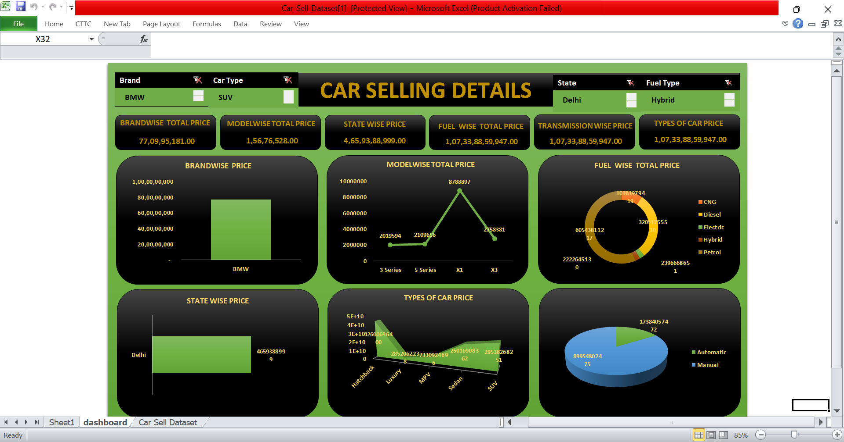
Key Insights from Excel:
- Worksheets and Cells: Data is stored in rows and columns within a grid of cells.
- Formulas and Functions: Automate calculations using built-in functions like SUM, IF, VLOOKUP, AVERAGE, etc.
- Charts and Graphs: Create visualizations like bar charts, pie charts, and line graphs.
- Pivot Tables: Summarize and analyse large datasets easily.
- Data Filtering & Sorting: Helps organize and view data based on specific criteria.
- Conditional Formatting: Highlight data based on values or rules.
- Macros: Automate repetitive tasks using VBA (Visual Basic for Applications).

MICROSOFT POWERBI
Power BI is a business analytics and data visualization tool developed by Microsoft. It enables users to connect to various data sources, clean and transform data, create interactive dashboards and reports, and derive meaningful insights.
Workflow of Power BI –
- Import Data → From Excel, SQL, Web, etc.
- Transform Data → Using Power Query (clean, merge, shape).
- Model Data → Create relationships, DAX formulas.
- Visualize Data → Charts, cards, maps, filters, slicers.
- Publish & Share → On Power BI Service, with access control.
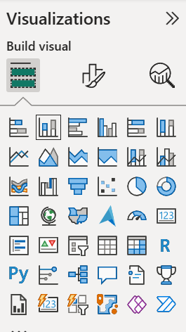

DATA VISUALIZATION USING POWER BI:
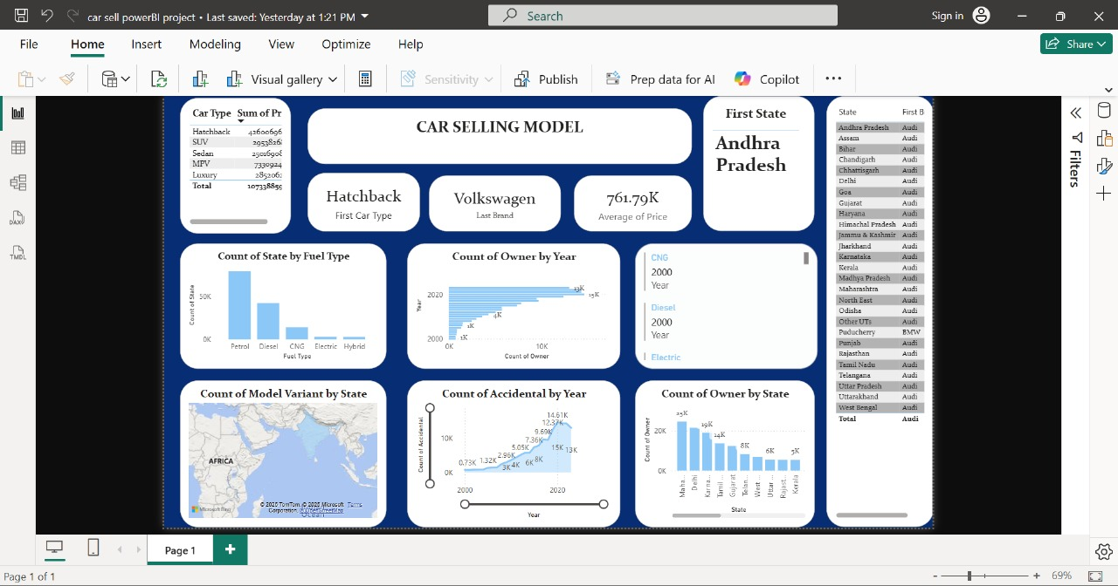

Advantages
- Easy to use with drag-and-drop features
- Powerful data modelling and DAX support
- Seamless integration with Excel and Microsoft 365

TABLEAU
A Tableau Dashboard is a visual display of key metrics and data insights combined in a single screen. It enables users to make data-driven decisions by presenting interactive charts, KPIs, maps, and filters in a visually intuitive format.
Data Source
The dataset used was from an Excel file titled "Ecommerce.xlsx". It included fields such as:
1.Car Name: Brand/model of the car
2.Year: Year of Purchase
3.Present Price: Current showroom price
4.KMS Driven: Distance driven in Kilometers
5.Transmission: Manual or Automatic
6.Owner: Number of previous owner
7.Seller Type: Dealer or Individual
Major Visual Components
- Map of India: Geographical distribution of car sales by brand per state, color-coded for intensity.
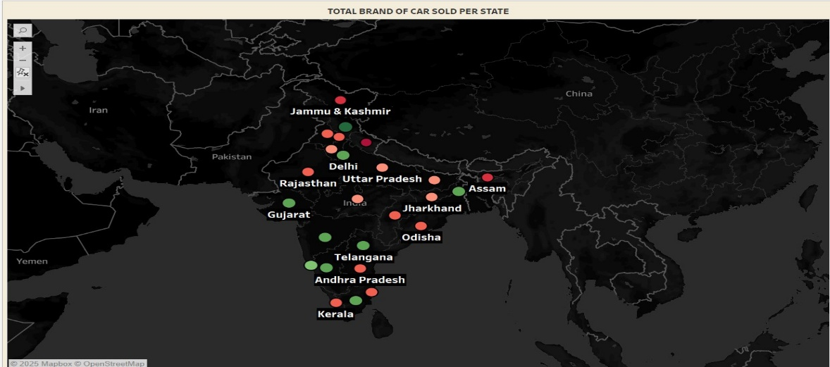
- Bar Chart - Brand Model vs Total Price Sold: Helps identify which models contribute most to brand revenue.
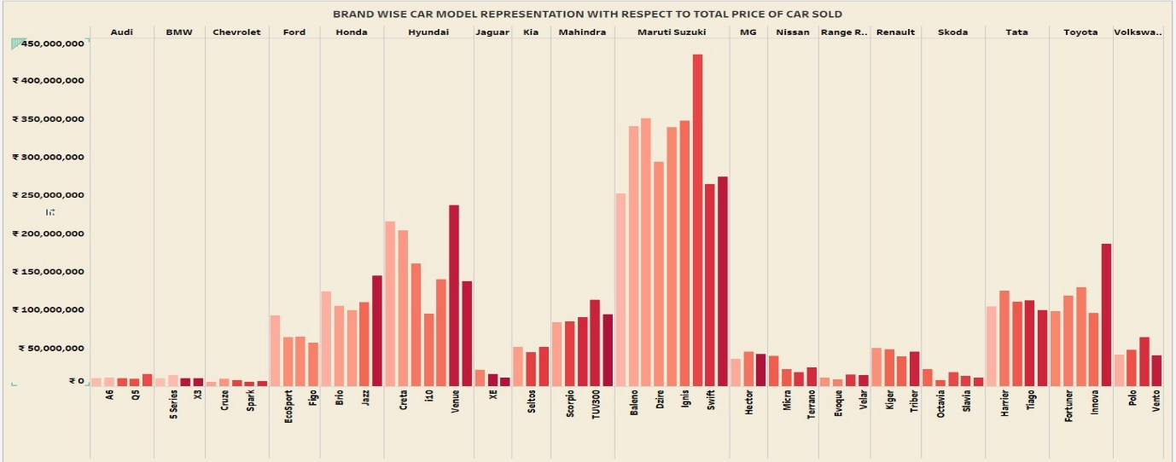
- Pie Chart - Top 5 Brands Sold in India: Quick summary of market leaders.
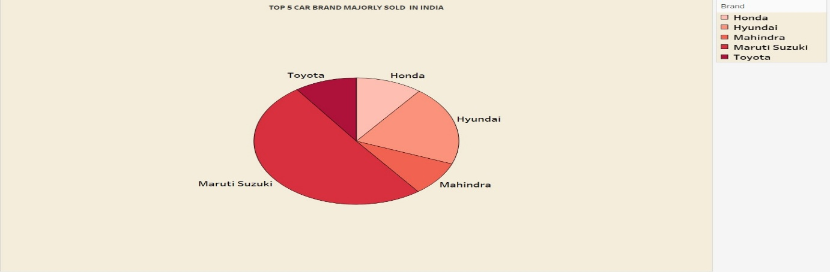
- Area Chart - Ownership Types: Shows ownership distribution trend, highlighting first-owner preference.
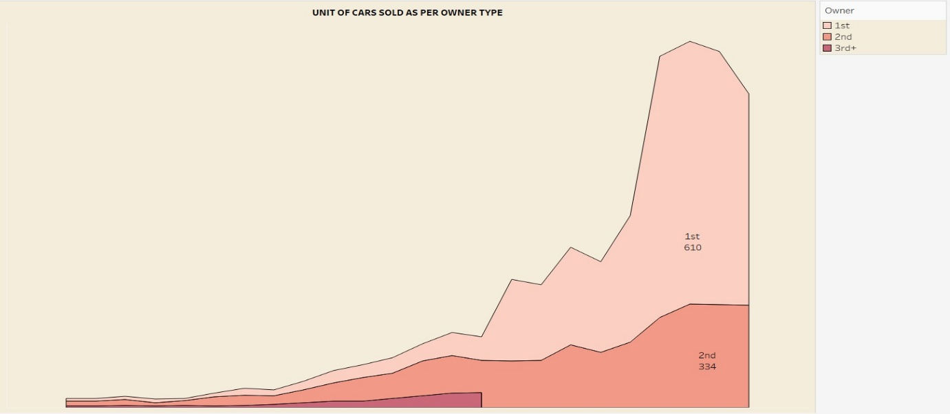
- Bar Chart - Avg. Selling Price by Brand: Ranking brands based on average resale price.
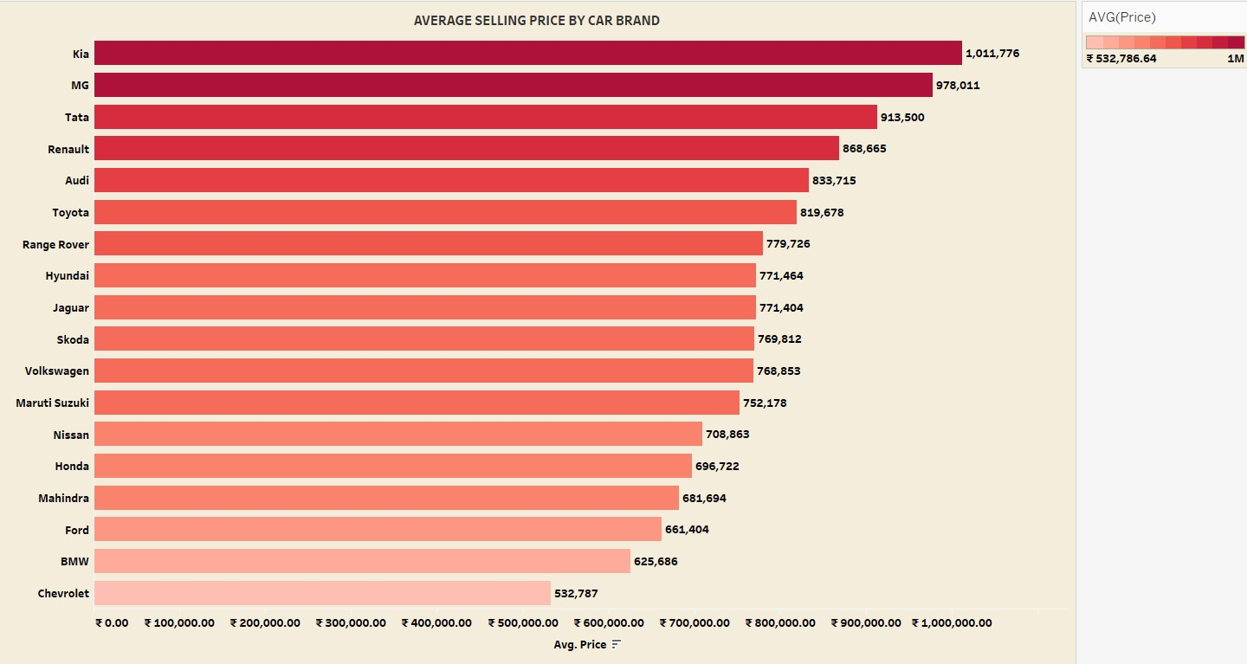
- Bubble Chart - Fuel Type Usage: Visual comparison of popularity across fuel types.
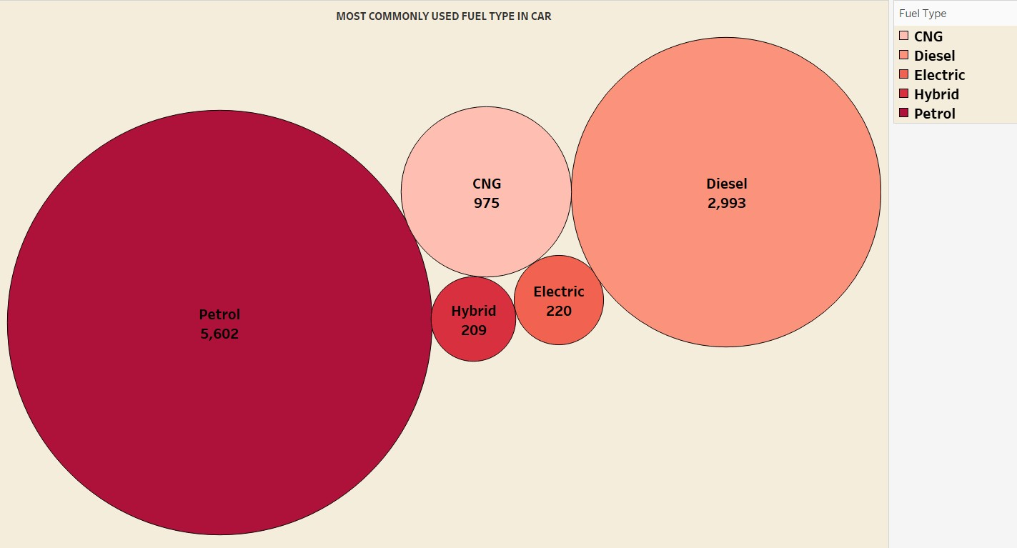

- Tree Map - Car Type Distribution: Categorization of cars into Hatchback, Sedan, SUV, MPV, etc.
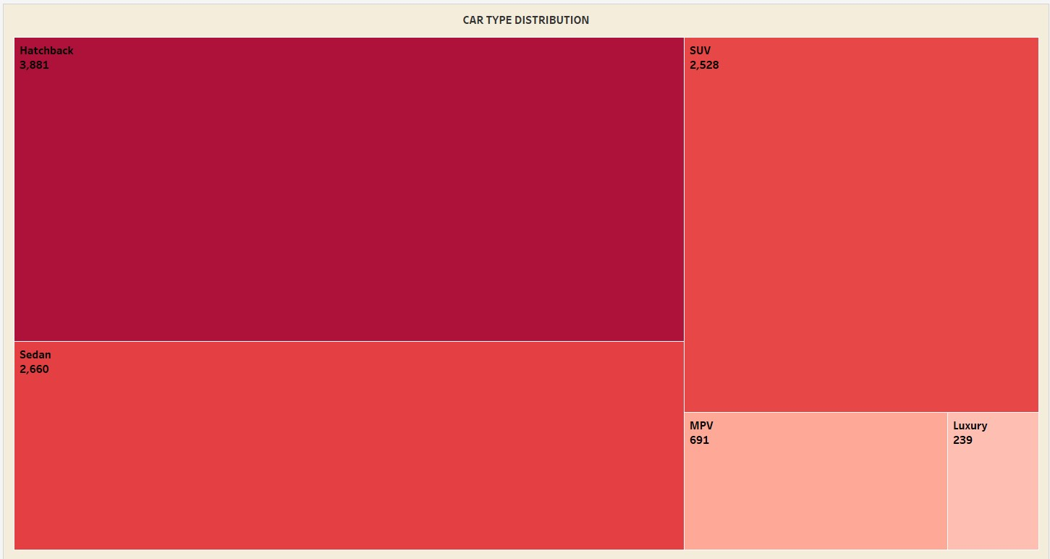
- Rectangle Chart - Transmission Types: Comparison between Manual and Automatic variants.
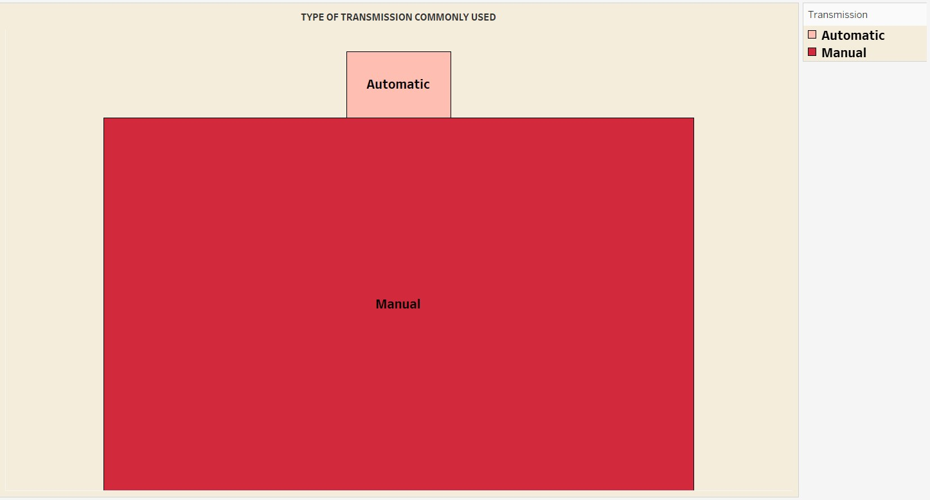
Key Insights
- Top Brands: Maruti Suzuki, Hyundai, Mahindra, Toyota, and Honda dominate the Indian car resale market.
- Manual vs. Automatic: Manual transmission still holds a significant majority over Automatic in the resale market.
- Fuel Type Trends: Petrol-powered cars lead in quantity, followed by Diesel. CNG has a smaller but notable share.
- Ownership Preference: First-owner cars are most in demand, indicating a preference for less-used vehicles.
- Price Leaders: Kia and MG exhibit the highest average selling prices, showing consumer willingness to pay premium for certain brands.
- Popular Car Types: Hatchbacks are the most common, followed by SUVs and Sedans.
- Geographical Highlights: States like Kerala show high volumes of sales, emphasizing regional buying behaviours.
DASHBOARD:
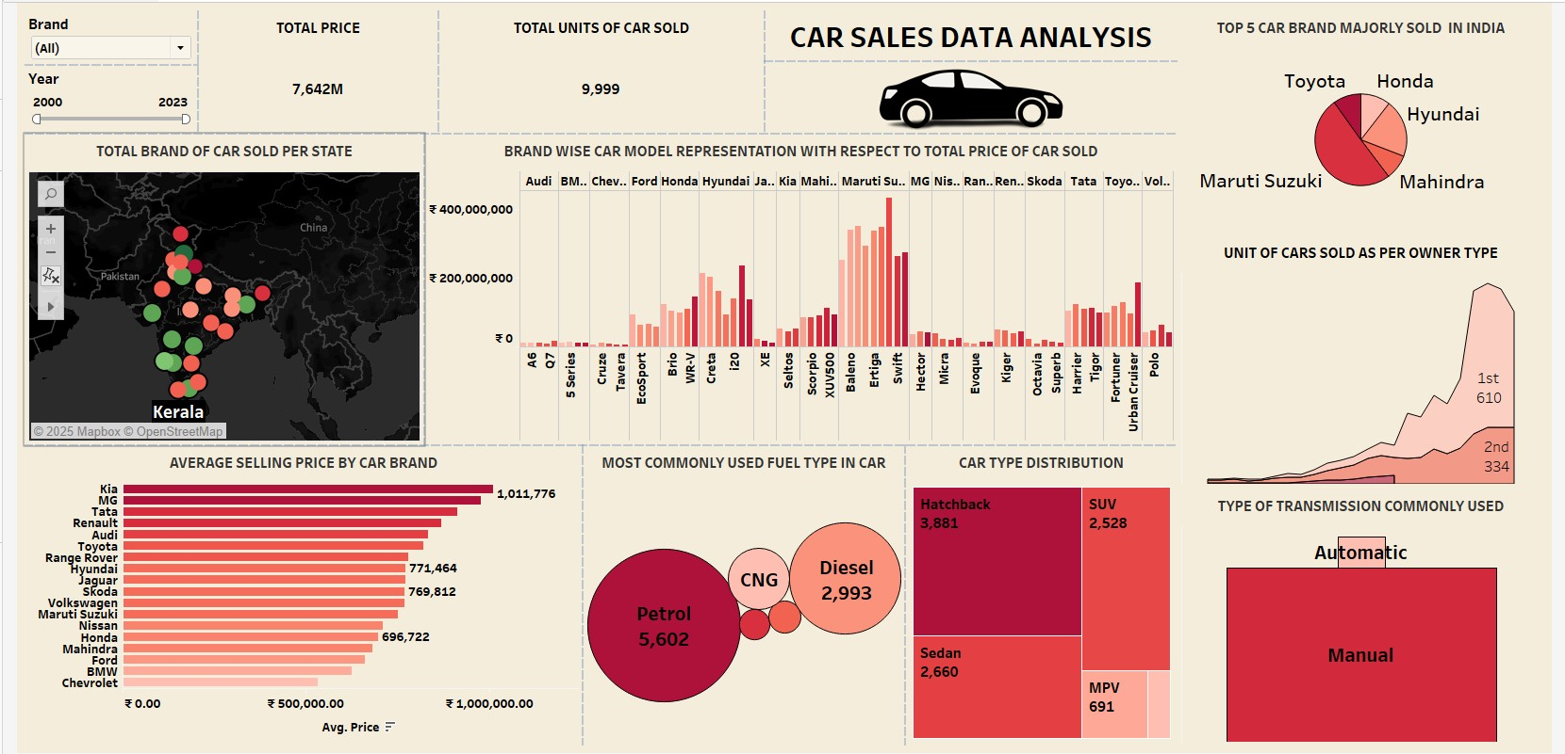

PYTHON:
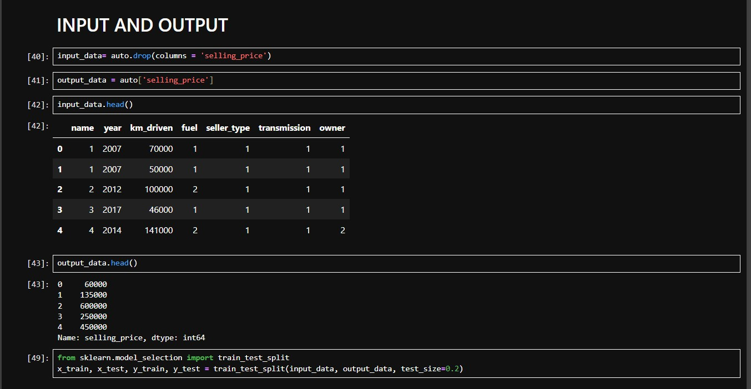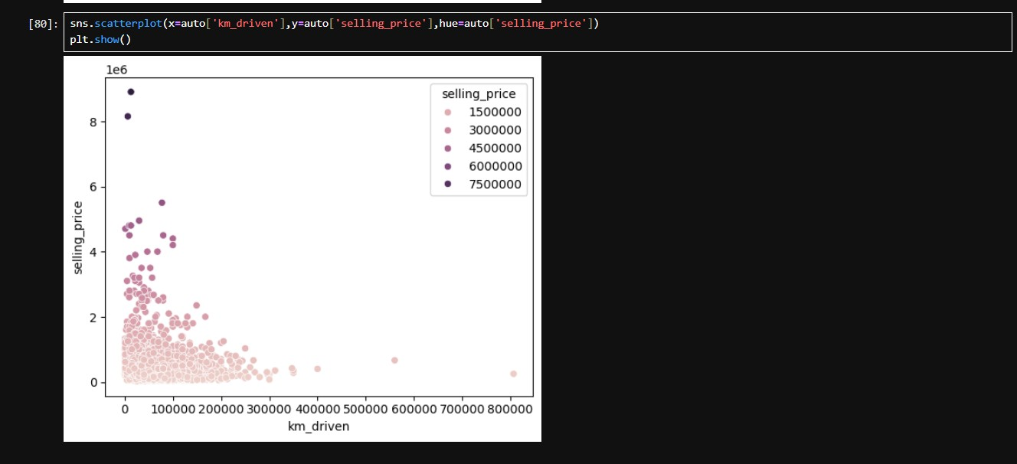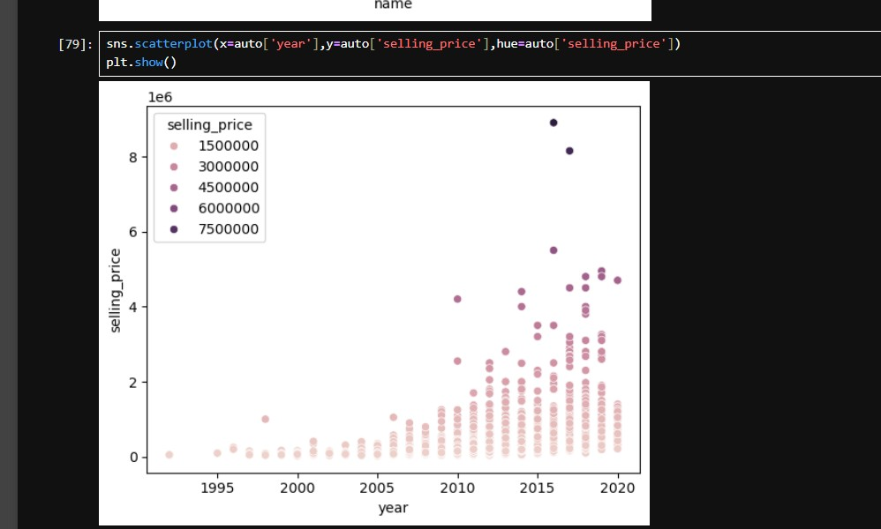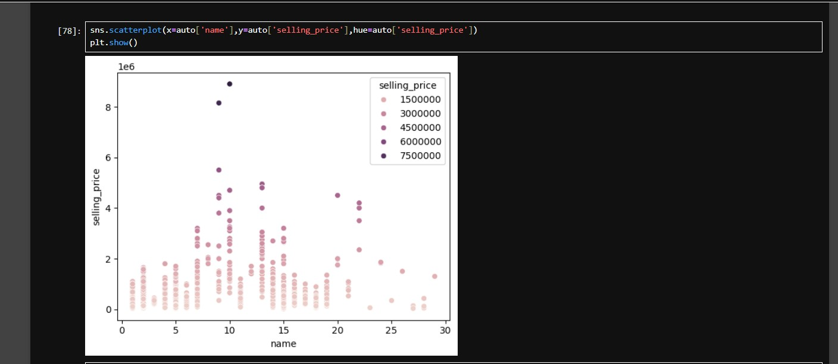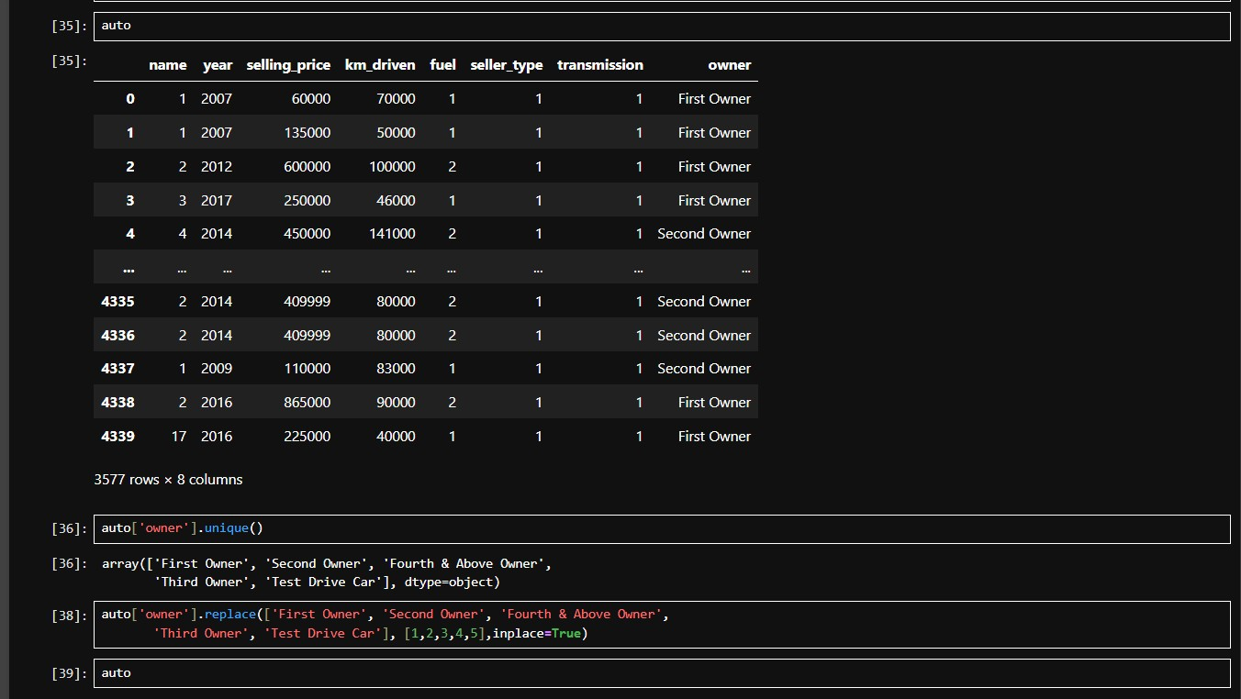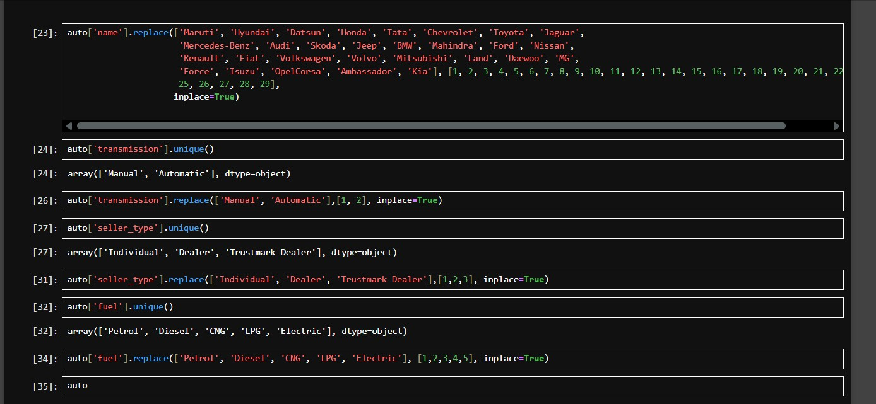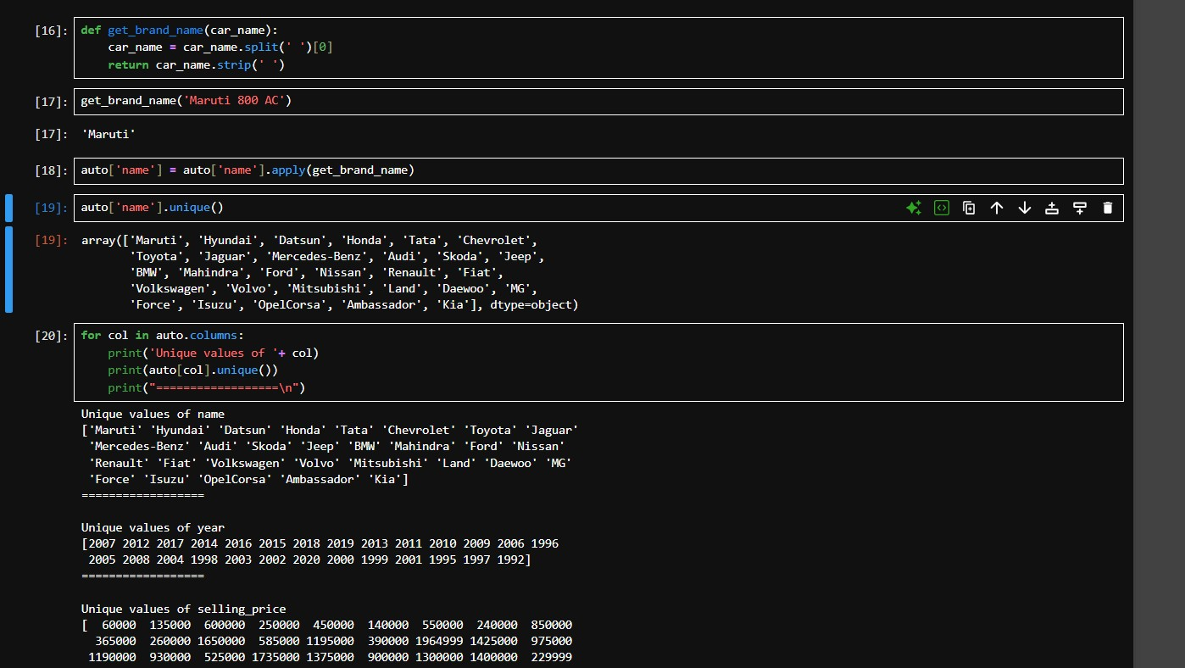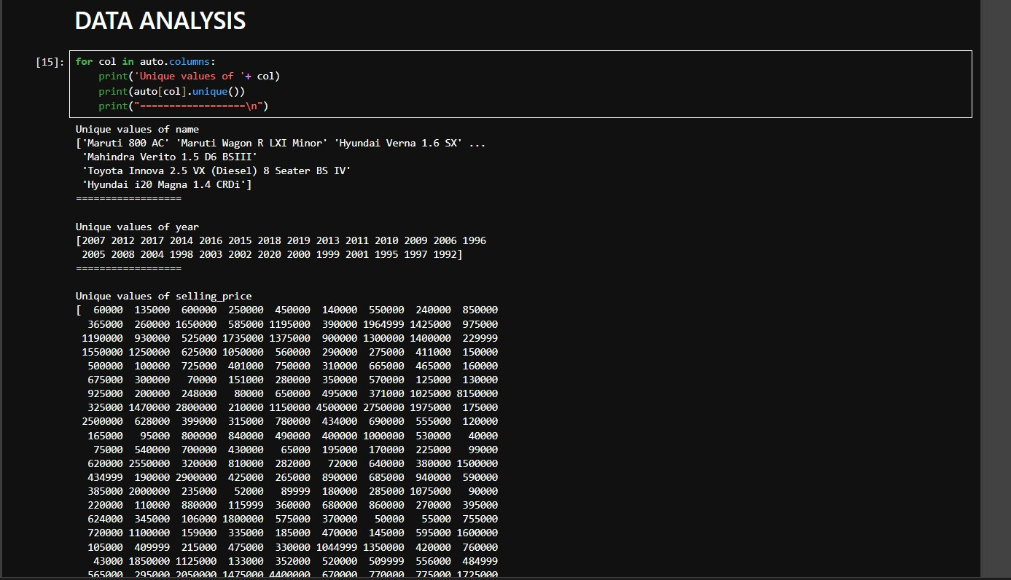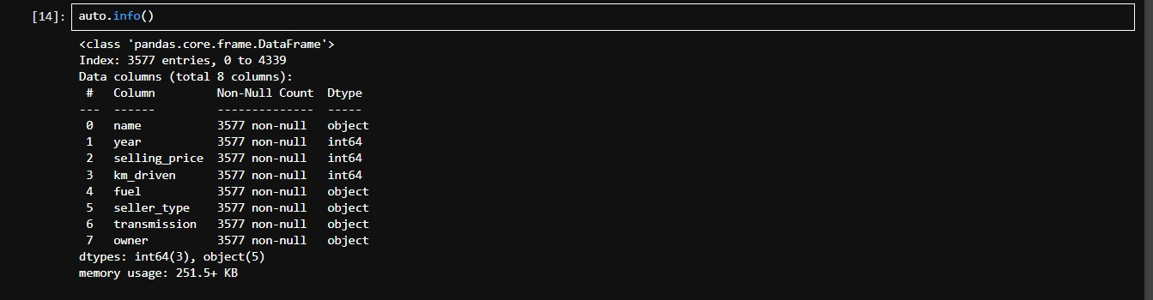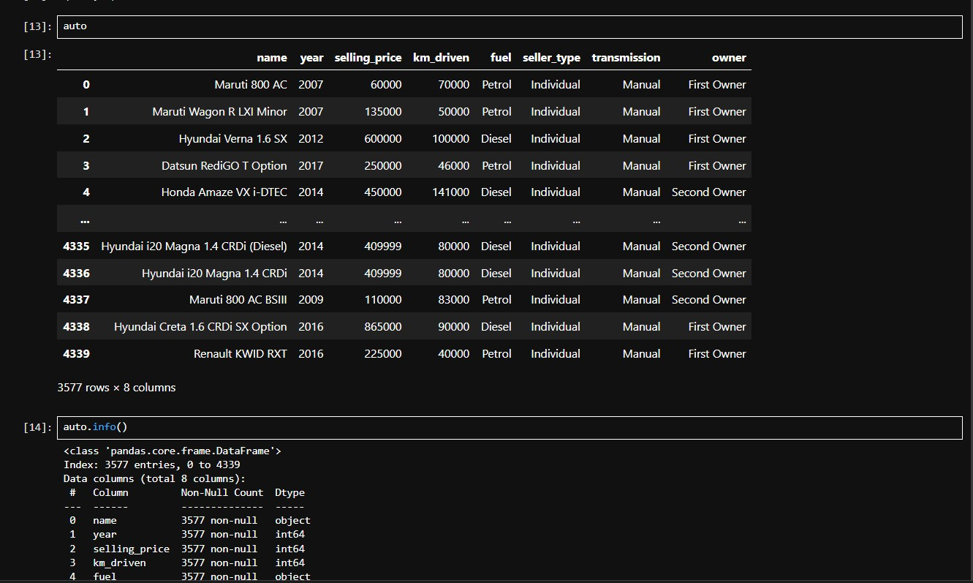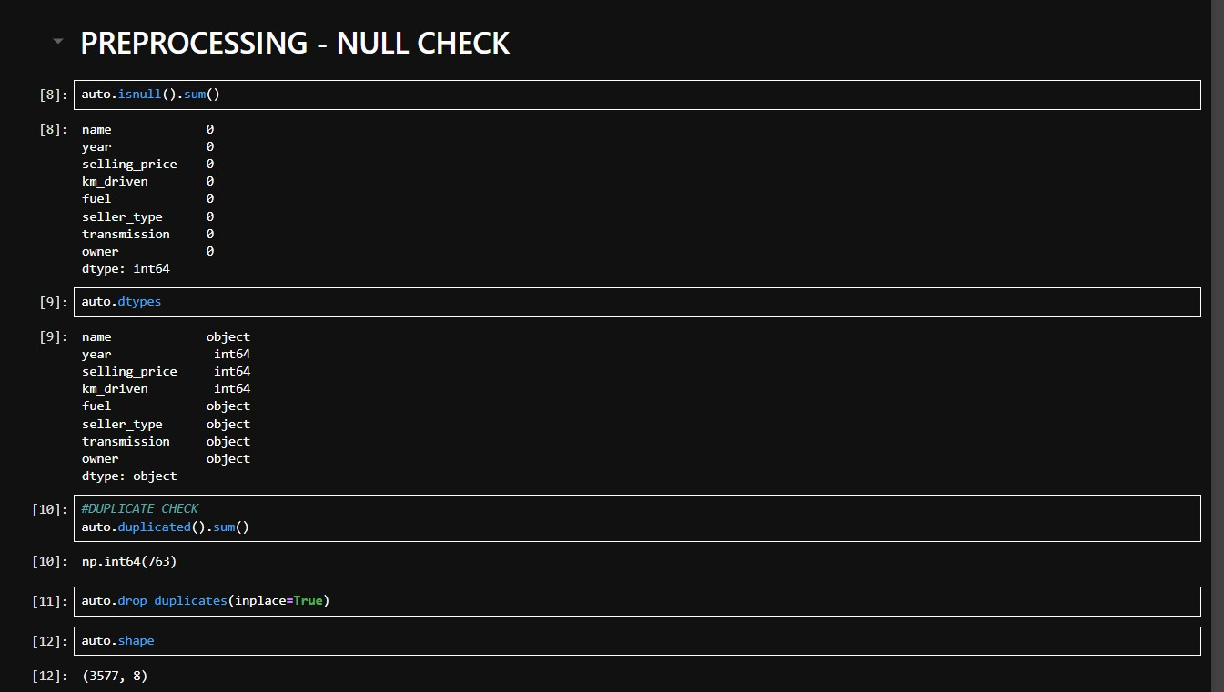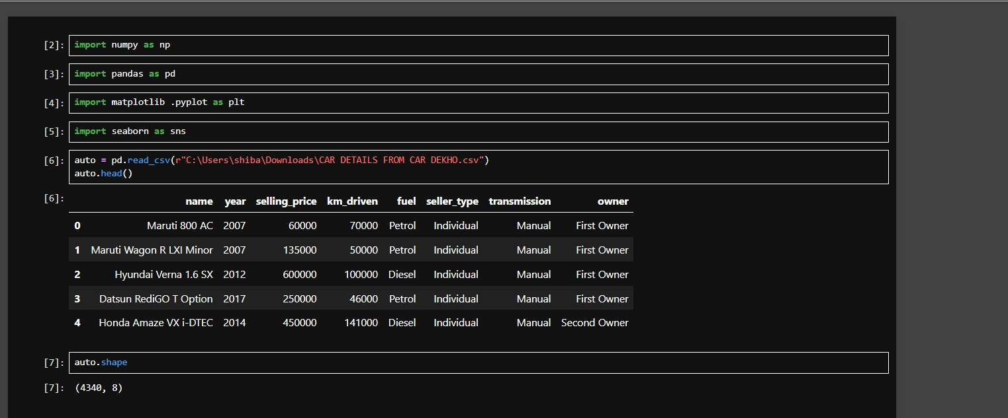
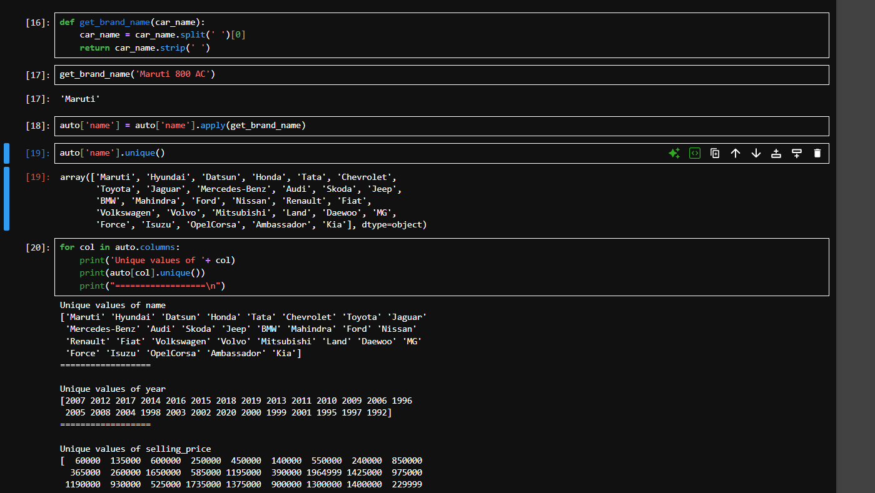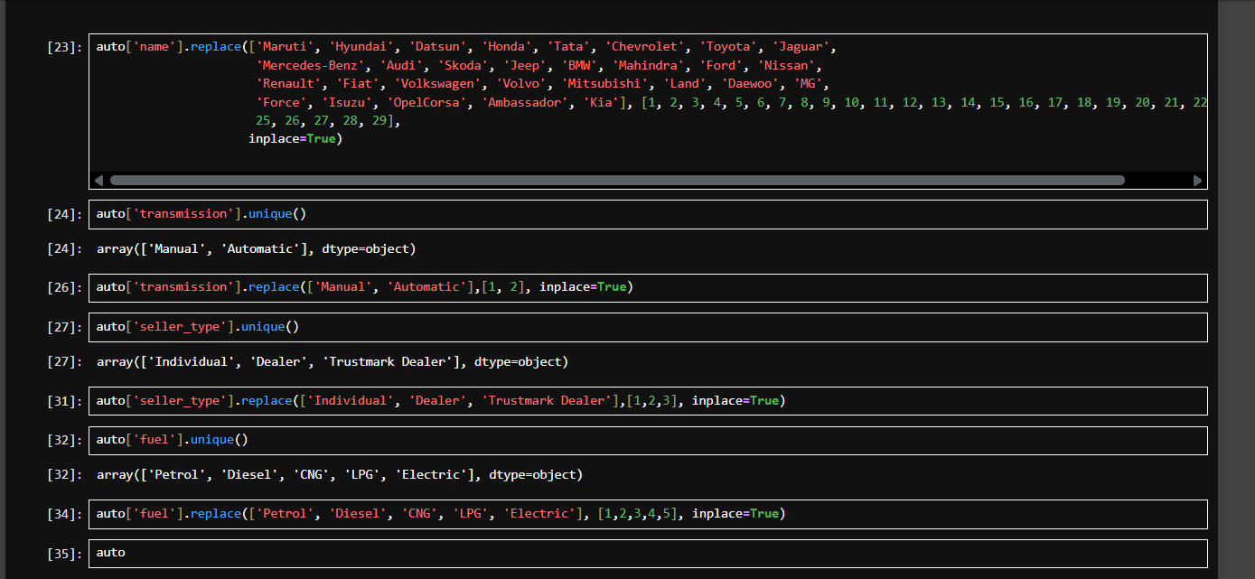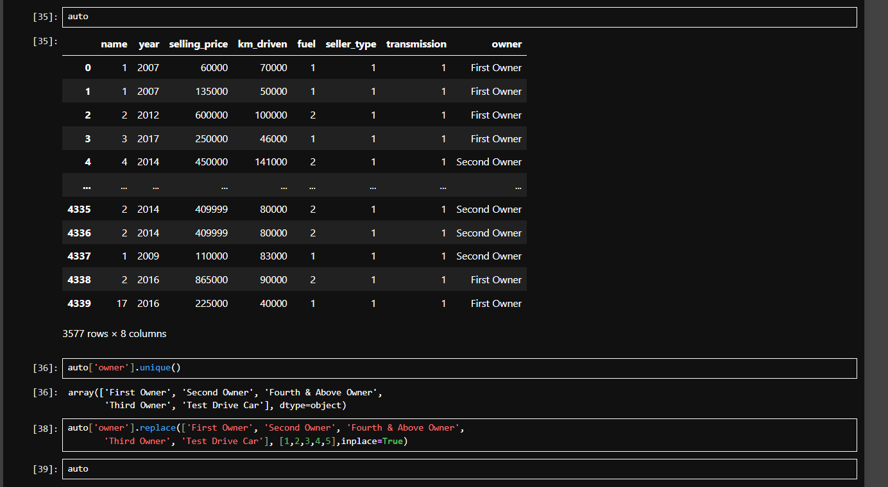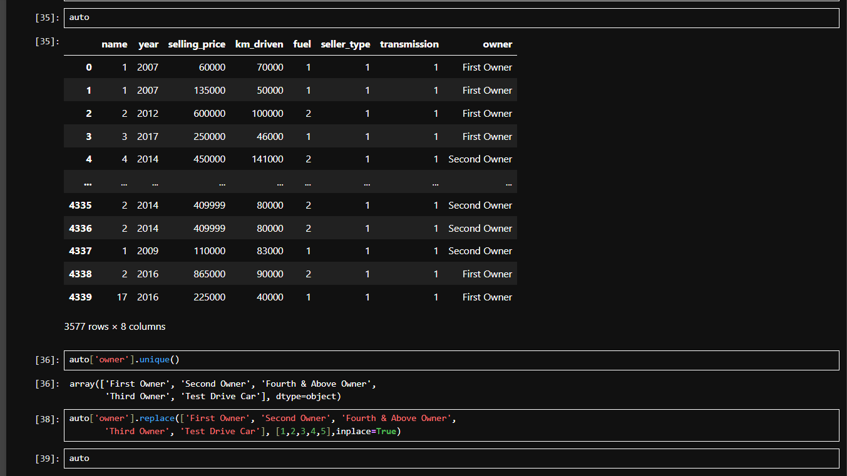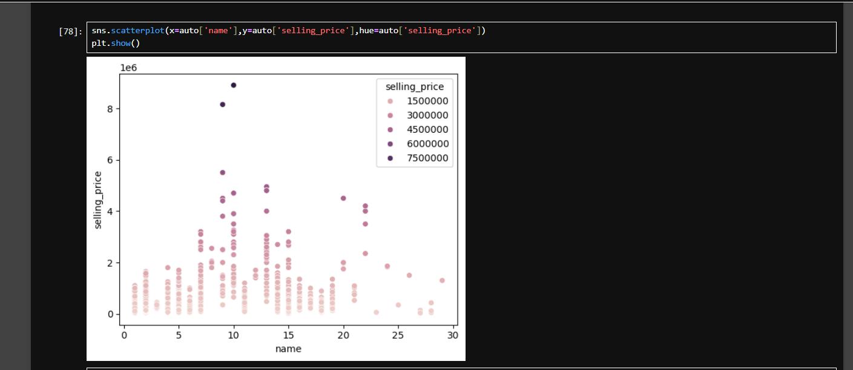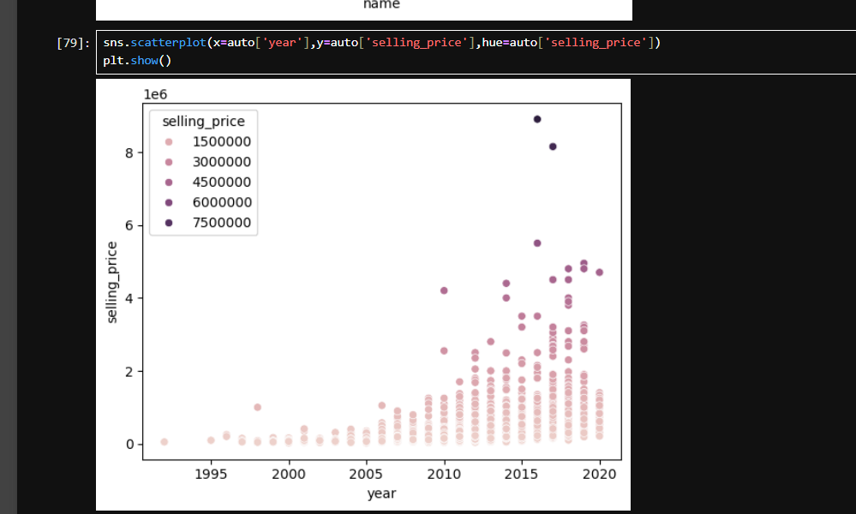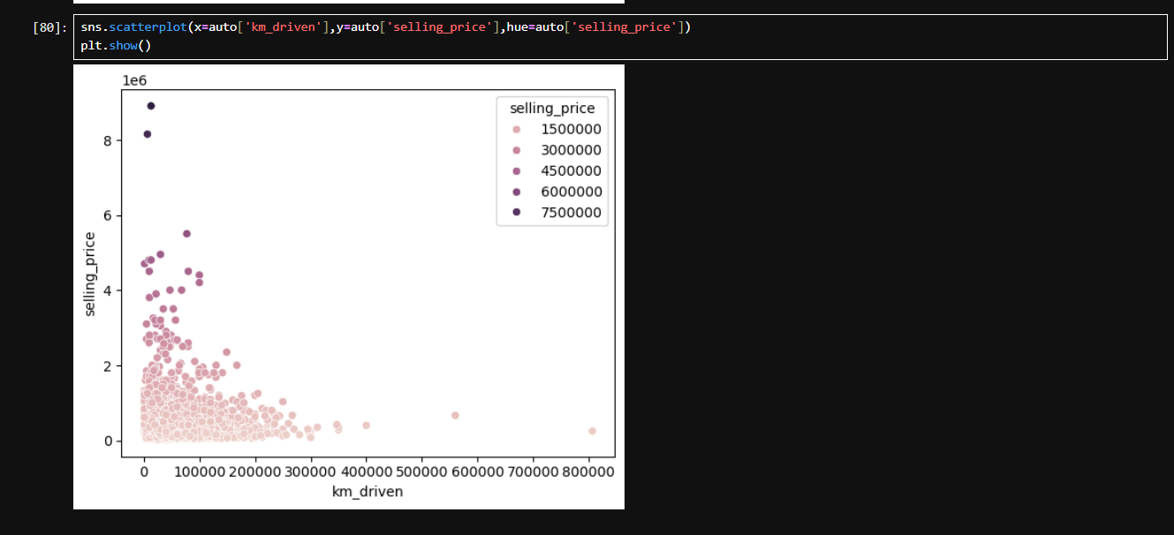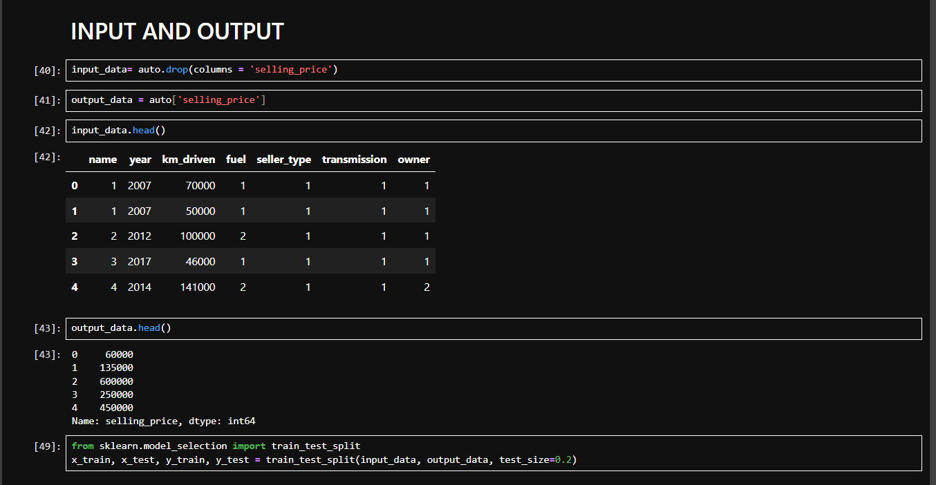
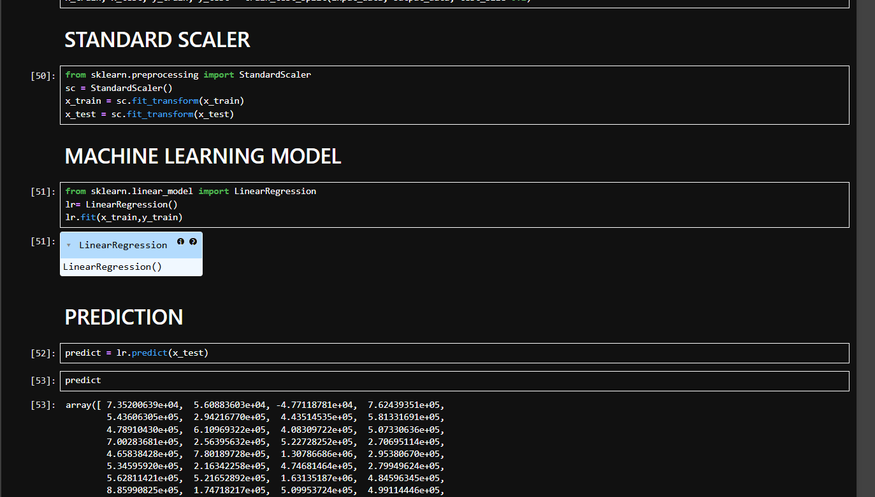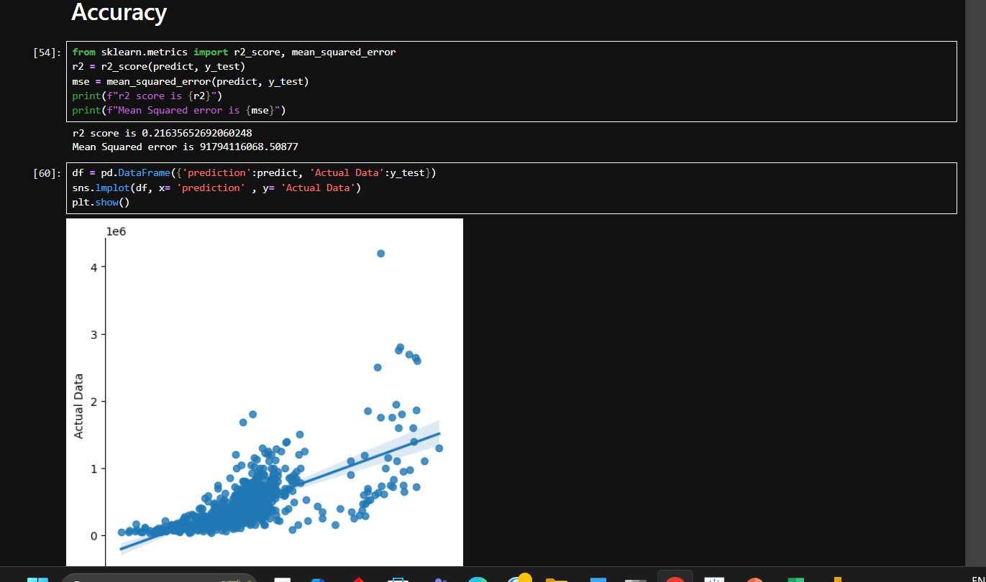
CONCLUSION:
The Car Selling Price Prediction Model developed in this project demonstrates the practical application of data analysis and machine learning techniques in solving real-world business problems. By analyzing historical data of used cars, we were able to identify key features such as present price, kilometers driven, fuel type, transmission, number of previous owners, and year of manufacture, which significantly impact the resale value of a car.
The preprocessing steps, including data cleaning, feature engineering, and encoding categorical variables, were crucial in preparing the data for model training. After experimenting with various regression algorithms—Linear Regression, Decision Tree Regressor, and Random Forest Regressor—we found that the Random Forest model provided the highest accuracy and robustness in predicting car selling prices. Its ability to handle non-linear relationships and complex feature interactions made it the best fit for this dataset.

